4 x 4 High Fixed / Dedicated RTT – CGEA1.3

Functional Description

The purpose of the 4 x 4 High RTT is to inform the driver that the vehicle is operating in four wheel drive high mode.

This STSS is to be used for a fixed / dedicated RTT on a TFT display.

The 4x4 High RTT correlates the AwdHiLamp_D_RqDsply signal originating from the TCCM, the module configuration, and the Operational Mode to illuminate or extinguish the 4x4 High RTT. The 4x4 High RTT shall provide an iconic representation that will illuminate or extinguish to inform the driver whether they are in 4x4 mode or some other mode.

Interfaces

Interface Context Diagram (I/O Block Diagram)
Figure 1: 4x4 High Fixed / Dedicated RTT Indication Context Diagram
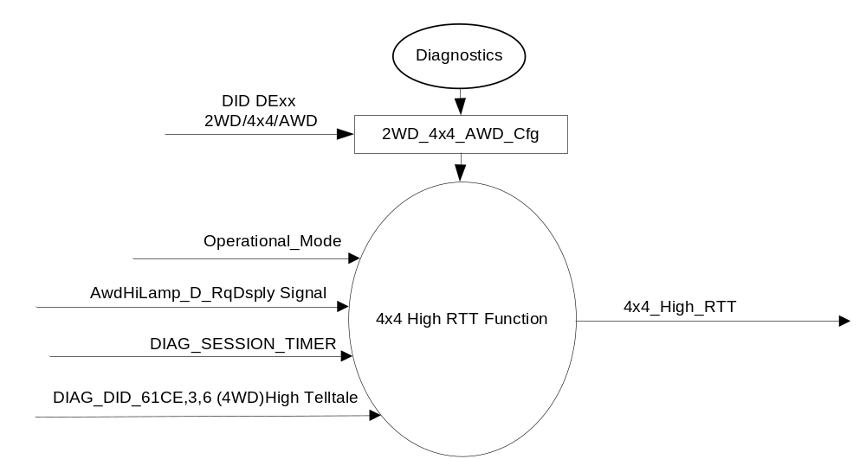

Inputs

      - INTERNAL:
            - 2WD_4x4_AWD_Cfg
            - Operational_Mode
            - DIAG_SESSION_TIMER
            - DIAG_DID_61CE,3,6 Four Wheel Drive (4WD) High Telltale
      - MUX message on the CAN Bus

- Signal AwdHiLamp_D_RqDsply
ID | Size  (bits) | Detail | Units | Res. | Offset | State Encoded | Min. | Max.
AwdHiLamp_D_RqDsply | 2 |  | SED | 1 | 0 |  | 0(0x0) | 0 3 (0x3)
 |  | Off |  |  |  | 0x0
 |  | On |  |  |  | 0x1
 |  | Flash |  |  |  | 0x2
 |  | Not_Used |  |  |  | 0x3

Outputs
- 4x4_High_RTT, which is used to control the state of the Reconfigurable Telltale (RTT).

Function/Performance

Operational Modes

Mode | Differentiating Vehicle Conditions
Sleep Mode | 4x4 High RTT OFF
Limited Mode | 4x4 High RTT OFF
Normal Mode | 4x4 High RTT ON/OFF
Crank Mode | 4x4 High RTT ON/OFF

Voltage Levels

Refer to the Cluster Features table located in the Operational Modes and Voltage Range Strategies section in this SPSS

Human-Machine Interface

Visual

Indicator Graphics / Display Format
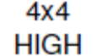

For actual symbol definition see abbreviations table in the approved Symbols list as per 03-0685 ARL requirement.

Indicator Color Coordinates

Amber - Reference SDS IL-0017/IS-0379

Indicator Characteristics

4x4 High RTT

Audio

None.

System Accuracy

The 4x4_High_RTT shall change the state of the RTT within 100msec of a state change as indicated in the state matrix reference 1.3.5.1 Subsystem Algorithm Flowchart / State Diagram.

Operation: Performance and Functional

Subsystem Algorithm Flowchart / State Diagram

Figure 2: 4x4 High Fixed / Dedicated RTT Diagnostic Flowchart

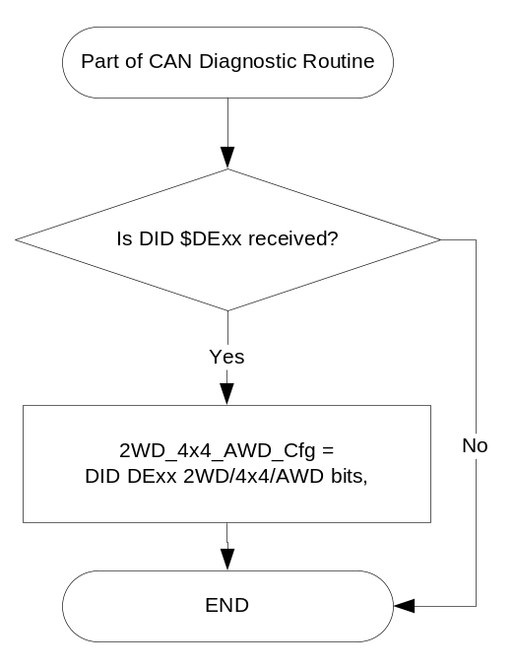

- State Matrix for 4X4_High_RTT
2WD_ 4x4_ AWD_ Cfg | Operational_ mode | DIAG_ SESSION_ TIMER | DIAG_DID_61CE,3,6 Four Wheel Drive (4WD) High Telltale | AwdHiLamp_D_RqDsply signal | 4x4_High  _RTT
4x4 | Normal or Crank | Not Active | X | ON (0x1) | ON
4x4 | Normal | Active | Not Received | ON (0x1) | ON
4x4 | Normal | Active | ON (0x1) | X | ON
All Other Cases |  |  |  |  | OFF
X=Don’t Care
Not Received = The state when a DIAG_SESSION_TIMER is active and the DID has not been received

Operation Description (supports algorithm flowchart /state diagram)
- 4x4 High RTT illumination is mutually exclusive with the 4x2 RTT, 4x4 Low RTT, and 4x4 Auto RTT and such 4x2 RTT, 4x4 High RTT, 4x4 Low RTT, and 4x4 Auto RTT are shown on the same space within the TFT.

- In the case of having more than one of the above RTTs active at the same time, the highest priority RTT will be illuminated. The priorities are as follows:

- 4x4 Low RTT (Highest Priority)
- 4x4 High RTT
- 4x4 Auto RTT
- 4x2 RTT (Lowest Priority)

- W740 will be the RTT display when 4x4_High_RTT is active.

Function Safety Classification (EMC)

Class B

Memory Storage
Parameter Name | Description | Value at  Battery Connect | Value at  Module Wake-up
4x4_High_RTT | Used to control the state of the LED | OFF (0x0) | OFF (0x0)
AwdHiLamp_ D_RqDsply | CAN signal sent from 4x4CM. | 0 (0x0) | 0 (0x0)
DIAG_DID_61CE, 3, 6 | Warning Lamp "B" Status byte 3 bit 6  Four Wheel Drive (4WD) High Telltale | Off (0x0) | Off (0x0)
2WD_4x4_AWD_Cfg | State indicator for feature presence controlled via CAN at EOL at VO plant. | Use Stored Value | Use Stored Value
Operational_Mode | 4 state indicator for cluster operational mode | Limited | Limited, Normal or Crank

Parameter Name | Description | Value at  Battery Connect | Value at  Module Wake-up
DIAG_SESSION_TIMER | Timer used to time-out a diagnostic session | Not Active | Not Active

Prove Out

None for RTT

Reconfigurable Telltale

Yes

Message Center Msg

None

Error Handling

Missing Message Strategy

The signals will be declared missing as per the Diagnostics section of this SPSS.

DTCs states and history will be determined as per the Diagnostics section of this SPSS.
If the 2WD_4x4_AWD configuration is not 4x4 (01), the cluster shall never log a missing message DTC due to this feature.

Diagnostics

Self Test

N/A.

Engineering Test Mode

Reference section “Dealer / Engineering Test Mode (ETM)”.

Part II Performance

DIDs
Number | PID / CommonID Name | PID Type
61CE | Warning Lamp "B" Status byte 3 bit 6  Four Wheel Drive (4WD) High Telltale | Bit Mapped

Supported Diagnostic Trouble Codes (DTCs)
DTCs shall be logged as per the diagnostic section of this SPSS.

DTC | Description
C10200 | Lost Communication with Transfer Case Control Module

DID DExx
Block  Num | Block Description | Size (bits) |  | Byte(s) | Bits | State: Description | "0" | "1" | Default | Comments/  Information
PACKETED BLOCKS
xx | Option Content (B&A) |  |  | * | 2 | 2WD/4x4/AWD | encoded | encoded | 01 - 4x4
 |  |  |  |  |  | 00 - 2WD | encoded | encoded
 |  |  |  |  |  | 01 - 4x4 | encoded | encoded
 |  |  |  |  |  | 10 - AWD | encoded | encoded
 |  |  |  |  |  | 11 – Not Used | encoded | encoded
*Byte and bit location to be identified in Part II Specification for this cluster

Reference Specification

FO-0007 FOUR WHEEL DRIVE MODE DISPLAY
FO-0008 FOUR WHEEL DRIVE FAULT INDICATOR

IS-0001 WARNINGS/INDICATORS/DISPLAYS PROVEOUT
IS-0046 INSTRUMENTATION MATERIAL RESISTANCE TO CLEANING
IS-0052 OPERATING VOLTAGES - FUNCTIONAL/PERFORMANCE
IS-0069 FUNCTIONAL IMPORTANCE CLASS
IS-0324 WINDSHIELD & OTHER REFLECTIONS
IS-0327 WARNING INDICATOR EVALUATION
IS-0329 FLICKERING OF LAMPS
IS-0379 NORTH AMERICAN WARNINGS AND INDICATORS STRATEGY

IL-0017 TELLTALE AND INTERIOR ILLUMINATION COLOR
IL-0021 CRAFTSMANSHIP - DISPLAYS
IL-0023 CLARITY/LEGIBILITY/READABILITY
IL-0025 INTERIOR ILLUMINATION INTENSITY
IL -0027 VISUAL CONTRAST
IL -0043 OPERATIONAL ENVIRONMENT FUNCTIONALITY
IL -0045 COLOR
IL -0047 TELLTALE; INDICATOR AND DISPLAY LIGHT INTENSITY
IL -0048 ILLUMINATION ACCEPTABILITY

03-0661 PLACEMENT: CONTROL AND DISPLAY LOCATIONS
03-0662 PLACEMENT: LOGICAL GROUPING FUNCTION AND USAGE
03-0664 PLACEMENT: DOWN VISION TO COMPONENTS WITH HIGH VISUAL DEMAND
03-0665 PLACEMENT: EXPECTED LOCATIONS OF CONTROLS AND DISPLAYS VDS
03-0670 INTERIOR VISIBILITY
03-0671 INTERIOR VISIBILITY: REFLECTIONS FROM COMPONENTS & SURFACES
03-0672 INTERIOR VISIBILITY: REFLECTIONS IN DISPLAYS
03-0673 INTERIOR VISIBILITY: VISUAL OBSCURATIONS
03-0674 INTERIOR VISIBILITY: ILLUMINATION CONTROLS / DISPLAYS
03-0675 INTERIOR VISIBILITY: VEILING GLARE
03-0677 INTERIOR VISIBILITY: SUNLIGHT WASHOUT
03-0681 IDENTIFICATION: CHARACTER AND SYMBOL SIZE
03-0682 IDENTIFICATION: LEGIBILITY
03-0685 IDENTIFICATION: SYMBOLS, ABBREV FOR CONTROL
03-0721 LOGIC OF OPERATION: OPERATIONAL STEREOTYPES
03-0722 LOGIC OF OPERATION: INTERPRETATION
03-0723 LOGIC OF OPERATION: USE OF SYSTEMS WITH VISUAL DISPLAYS

Revision History

SPSS Module Revision History

Revision Level | Name | Change Description | Date
1.0 | Jblatchf | From 4x4 High TT.Prior intent was to use the TT STSS for Fixed /Dedicated RTT applications. This is not feasible because:  - Fixed 4x4 High LED telltale proves out 4x4 High RTT does not.  - Fixed 4x4 High LED telltale performs All Telltale On diagnostics 4x4 High RTT does not.  - 4x4 RTT telltales are shown in same space as other 4x4 RTTs.  Specific Changes:  - Changed 4x4 High Telltale to 4x4 High RTT throughout  - Removed Bulb_Proveout_Timer throughout.  - Removed Bulb ETM Bulb check throughout.  - 1.3.5.3 added note regarding use of shared space for the other 4x4 RTTs.  - Add (4WD) High Telltale DID 61CE throughout | 10/22/12
1.1 | Jblatchf | This change corrects typo in table 1.1.  - Remove row from Table 1.1. | 1/2/13
1.2 | S. Watkins  M. Hakim | This update is to add priority listing for 4x2, 4x4 Auto, 4x4 High, and 4x4 Low Fixed/dedicated RTTs. Also to update DID DE00 to DExx and update configuration values. Adding W# and removing “Self Test”, as well as STSS cleanup.  Section 1.1: Identified the source module from where the signal AwdHighLamp_D_RqDsply signal originated.  Section 1.2.1: - Updated title.  - Updated the configuration DID number from “00” to “xx” to accommodate the extended number of configuration DIDs.  Section 1.2.2: - Added 2WD_4x4_AWD_Cfg to the Internal Inputs.  - Removed specifying the CAN bus and the input signal source module name.  - Table 1.0: Corrected typo for the Max signal value to 3.  Section 1.3.5.1: - Added figure number and title to the Diagnostic Flowchart.  - Updated DID DE00 to DExx in the Flowchart.  - Removed the functional flowchart, as it is not needed  (the State Matrix table is sufficient)  Table 1.1: - Switched order of the first two columns.  Section 1.3.5.2: - Added the word “illumination”.  - Added priority listing for 4x2, 4x4 Auto, 4x4 High, and 4x4 Low Fixed/dedicated RTTs.  - Added W# for the 4x4_High_RTT (W740)  Section 1.3.5.4: Memory Storage:  - Added the parameter “2WD_4x4_AWD_Cfg” to the table.  Section 1.5.1:Self Test: Updated to be N/A.  Section 1.5.3: Part II Performance: - Updated DID DE00 to DExx.  - Added State Description “11 – Not Used” and “01” for Default.  Updated document footer. | 8/21//2013

